*RRT*

*Using probabilistic goal-biasing*

Umaid M. Zaffar, Marium Aslam, Immad Amir, Mustafa Asim

SEECS, NUST, H12, Islamabad, Pakistan

{uzaffar, maslam, iamir, masim}.bscs17seecs@seecs.edu.pk

***Abstract*—***Motion planning is an underlying area of research in robotics. Sampling- based algorithms have proved themselves to be quite efficient in path searching and motion planning problems. Rapidly exploring random trees or RRT is a simple single-query search algorithm for highly dimensioned configuration spaces. It works by incrementally building a tree from randomly drawn samples from the search space. The tree is rooted at the start point; a random seed is generated at each incremental expansion whilst the Euclidian distance is calculated from the existing nodes in the tree, the nearest node, from where the expansion has originated, is highlighted. (Based on certain rules, one of them is selected as the next to be expanded). The last node, at which expansion ceases, is the goal node. The large scale of data provided by the RRT makes its running a challenging task. The path provided is not the shortest nor most feasible, in any way due to its nature of random expansion.*

*Our goal is to optimize the basic algorithm by adding simple modifications and efficient uniform goal-biasing at regular intervals.*

*Recently, much work has been carried out in optimizing the RRT. RRT* extends RRT by smoothening the highly random path i.e. apart from connecting the parent node to the child node, it also inspects the neighborhood and if one node is found to trace up to the tree root via child at a shorter distance than the current connection, parent of this node will be shifted to child. This optimized algorithm, although does effectively find the optimal path, but it needs to search every state from the initial state making it inefficient and also contrary to single-query of RRT. A recent research presents goal-biased informed RRT*. Goal biasing is used in the algorithm and once an initial path is found an ellipsoidal subset is constructed in the sample space for refined planning. [1]*

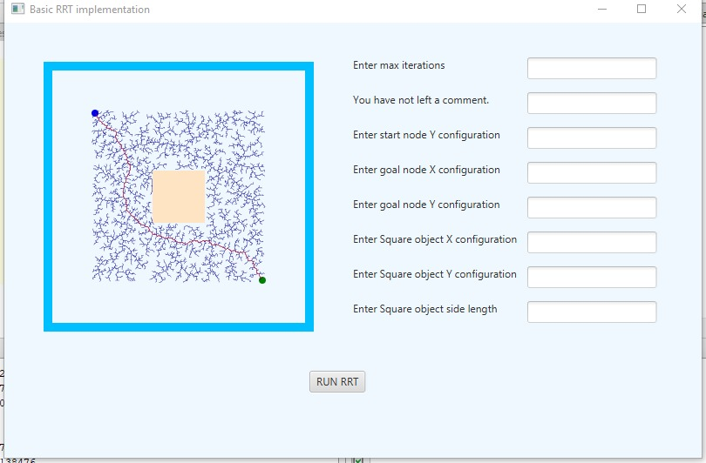

**Figure 1: basic visual representation of Secure-RRT functioning**

*Another research takes a different approach. RRT-Connect [2] works by incrementally building two random trees, one rooted at the start node and the other on the goal configuration. Both trees explore space and also advance towards each other by using a greedy heuristic.*

*PaRRT [3] is a new extension of the RRT that parallelizes it by using MapReduce; a programming model that generates chunks of data from large datasets and processes them in a parallel manner.*

*This research [4] provides several modifications to the basic RRT by utilizing heuristic quality function to guide the search. The growth of the RRT is biased by discovering costs through exploration of space. This provides extra information for the algorithm to operate in more than just an exploratory manner.*

*This paper presents a new and simple variant of RRT, with intermittent goal-biasing at each interval. The new-nodes are goal biased that are set to sample the goal after generating specified number of nodes in any direction on the condition that there is no obstacle interference in the configuration of the new node. The most significant process that provides support for goal biases is the uniform random generator which generates a number that has as much probability of coming up as any other number e.g. on a scale of 1 to 10 the probability of a number ranging from 0 to 1 has 10% chance of being generated. This allows the program to not only explore unnecessary areas but also reach the goal as soon as possible. Experimental results indicate that this approach is significantly more efficient and ten times faster in finding the path.*

***Keywords—****Euclidian distance, goal-biasing, heuristic*